NAME: VENKATRAMAMOORTHY.G
- Write a program to filter a list of names. Use textbox, and ul. On typing the letters in the textbox the list should be filtered.
CODE:
function check(a,b){
for(let i=0;i<a.length;i++){
let str=''
str+=b[i];
let str1=''
str+=a[i];
console.log(str);
if(a[i]===b){
return true;
}
else if(a===b){
return true;
}
else if(str1===str){
return true;
}
}
return false
}
function filter(){
let ul=document.getElementById('ul');
let li=ul.querySelectorAll('li');
let input=document.querySelector('input').value;
input=input.toLowerCase();
for(let i=0;i<li.length;i++){
let element=li[i];
let val=element.textContent.toLowerCase();
if(check(val,input)){
element.hidden=false;
}
else{
element.hidden=true;
}
};

}
OUTPUT:
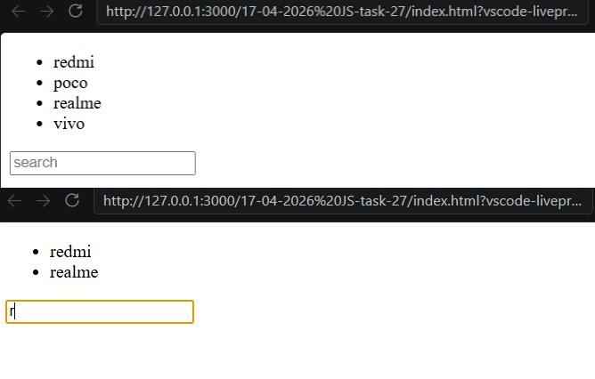
- Display a list of cards containing movie name and image using javascript.
CODE:
let movielist=['jan nayagam','lik','dude','vada chennai','conjuring','kara','beast','jho'];
let ul=document.getElementById('ul');
console.log(ul)
movielist.map(value=>{
console.log(value);
let li=document.createElement('li');
let img=document.createElement('img');
let div=document.createElement('div');
let p=document.createElement('p');
p.textContent=value;
img.src="https://picsum.photos/200";
li.appendChild(div);
div.appendChild(img);
li.appendChild(p);
ul.appendChild(li);
});
OUTPUT:
